Trace table
Test Case | First Number | Second Number | Expected Result
1.  Normal Scenario | 14 | 35 | 7
2  (Where one of the numbers is the HCF) | 7 | 49 | 7
3.  When the first number is bigger than second | 16 | 12 | 4
4.  No common factor except 1 | 84 | 13 | 1
5.  Two numbers are the same | 5 | 5 | 5

SCREENSHOTS SHOWING THE RESULTS
1.
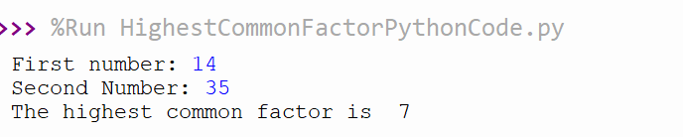
2.
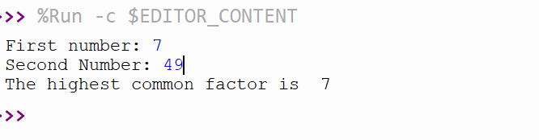
3.
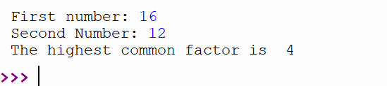
4.
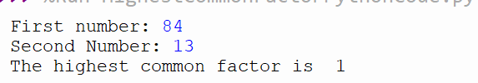
5.
